**Use Case Diagram**

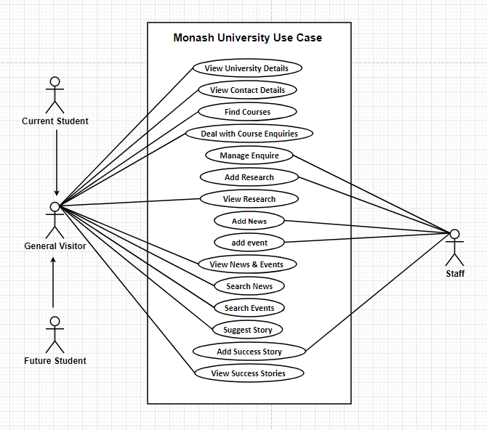

**Figure: Use Case Diagram of Monash University**